|  |
| --- |
| Project Document |
| Product Management App (App Quản lý sản phẩm) |

|  |  |
| --- | --- |
| QLSP | |
| **Group Members** | Mai Quang Khải - Frontend Developer - HE171102 |
| **Supervisor** | None |
| **Project code** | QLSP |

Hanoi, 03/2025

**Table of Contents**

Acknowledgement 3

Definition and Acronyms 3

I. Project Introduction 4

1. Overview 4

2. Product Background 4

3. Project Scope & Limitations 4

4. Project Deliverables 5

II. Project Management Plan 6

1. Configuration Management 6

III. Software Requirement Specification 8

1. Product Overview 8

2. User Requirements 8

3. Functional Requirements 8

IV. Release Package & User Guides 8

1. Deliverable Package 8

2. Installation Guides 9

3. User Manual 14

# Acknowledgement

In today's dynamic marketplace, efficient product management is paramount for success. Introducing QLSP, a mobile-first solution meticulously designed to streamline your entire product lifecycle, right from the palm of your hand. Whether you're a budding entrepreneur with a single offering or a growing business managing a diverse catalog, QLSP provides the intuitive tools you need to organize, track, and present your products effectively, all on the palm of your hand.

Inspired by the need for a seamless and accessible product management experience, QLSP offers a user-friendly interface tailored for the Vietnamese market. From effortlessly adding new items with essential details like name, price, and captivating visuals, to easily viewing and managing your existing product inventory, this application empowers you to stay in control, make informed decisions, and ultimately drive growth for your business. Get ready to simplify your product management and focus on what truly matters: delivering exceptional products to your customers.

# Definition and Acronyms

|  |  |
| --- | --- |
| **Acronym** | **Definition** |
| BA | Business Analysis |
| BR | Business Rule |
| ERD | Entity Relationship Diagram |
| GUI | Graphical User Interface |
| PM | Project Manager |
| SDD | Software Design Description |
| SPMP | Software Project Management Plan |
| SRS | Software Requirement Specification |
| UAT | User Acceptance Test |
| UC | Use Case |
| API | Application Program Interface |

# I. Project Introduction

## 1. Overview

### 1.1 Project Information

* Project name: **QLSP**
* Project code: **QLSP**
* Software type: **Mobile App, Web API**.

### 1.2 Project Team

#### Team Members

|  |  |  |  |
| --- | --- | --- | --- |
| **Full Name** | **Role** | **Email** | **Mobile** |
| Mai Quang Khải | Member | khaimqhe171102@fpt.edu.vn | 0365068967 |

### 

## 2. Product Background

### 2.1. Reasons to develop this project

Developing this Product Management mobile application addresses several key needs and presents compelling reasons for its creation, particularly within the context of TEKO's business and the broader market: To meet such challenges, our team has created an app that will cater to the needs of its staff.

**Hiring Test Objectives for TEKO:**

* **Evaluating Mobile Development Skills:** This project serves as a practical test for evaluating the technical skills of Mobile Engineer candidates, including UI development, state management, API integration (even if mocked for the test), and adherence to best practices.
* **Assessing Problem-Solving Abilities:** Candidates need to demonstrate their ability to understand the requirements, design a solution, and implement it effectively.
* **Understanding of Product Management Concepts:** The test implicitly assesses the candidate's understanding of basic product data and management workflows.
* **Evaluating Code Quality and Architecture:** TEKO can assess the candidate's coding style, organization, and overall software architecture through this project.

In conclusion, developing this Product Management mobile app offers significant benefits for TEKO ,serving as a valuable tool for evaluating potential Mobile Engineering talent.

## 3. Project Scope & Limitations

### 3.1 Major Features

The QLSP platform will provide users with a flexible solutions. Key features include:

|  |  |  |
| --- | --- | --- |
| **FE** | **Name** | **Description** |
| 01 | Product Creation | Users can create products with the given forms: Name, Price and Picture (from local device) |
| 02 | Product Management | Users can manage the product list, including add, edit and delete products (will be further implemented in the future since the given API only allows for a product list fetch) |
| 03 | Product View | Users can choose either viewing the product list with gridview or listview. |
| 04 | Product Search | User can type in the product that they want to search, and the list will be filtered out. |
| 05 | In-App Notifications | Users receive notifications for in-app actions, either confirmation notifications or error notifications. |

*Table: Major features of the QLSP system*

### 3.2 Limitations & Exclusions

|  |  |
| --- | --- |
| **FE** | **Description** |
| 01 | **No real CRUD features**: Having already mentioned, this project is only provided with a REST API URL link for storing data structure, which is only for analyzing and parsing to render the UI. |

*Table: Limitations & Exclusions*

## 4. Project Deliverables

|  |  |  |  |
| --- | --- | --- | --- |
| **#** | **Deliverable** | **Due Date** | **Notes** |
| 1 | Project Report | 20/03/2025 |  |
| 2 | App coding & deployment | 20/03/2025 |  |

*Table: Project Deliverables*

# II. Project Management Plan

## 1. Configuration Management

### 1.1 Document Management

All project documents will be managed using Google Drive, a cloud-based file storage and sharing platform. The following outlines the process and protocols for document management:

#### 1.1.1 Document Storage

* **Centralized Repository**: Microsoft One Drive will serve as the centralized repository for all project-related documents, ensuring that all team members have access to the latest versions.
* **Folder Structure**: A well-organized folder structure will be established within OneDrive to categorize documents by type.

#### 1.1.2 Version Control

* **Version History**: Google Drive’s built-in version history feature will be used to track changes to documents. This allows team members to revert to previous versions if necessary and ensures that changes are documented.

#### 1.1.3 Access Control

* **Permissions**: Access to specific folders and documents will be controlled using OneDrive’s permissions settings. Different levels of access (e.g., view, edit) will be assigned based on team members' roles and responsibilities.
* **Collaboration**: Team members can collaborate in real-time on documents using Google Drive sharing features, which support simultaneous editing and commenting.

#### 1.1.4 Backup and Security

* **Automatic Backup**: Google Drive automatic backup feature ensures that all documents are regularly backed up, protecting against data loss.
* **Data Security**: Google Drive provides robust security features, including encryption and multi-factor authentication, to protect project documents from unauthorized access.

### 1.2 Source Code Management

The project’s source code will be managed using **GitHub**, a widely used platform for version control and collaboration. The following outlines the process and practices for source code management:

#### 1.2.1 Repository Structure

* **Central Repository**: A central repository will be created on GitHub, which will serve as the primary location for all source code, documentation, and related files.
* **Branching Strategy**: The project will follow a branching strategy to manage code changes. Key branches include:
* **Main Branch**: The stable branch that always contains the production-ready code.

#### 1.2.2 Version Control Workflow

* **Commit Practices**: Developers will commit their changes frequently with clear, descriptive commit messages that explain the purpose of each change.
* **Pull Requests**: All changes will be submitted via pull requests, allowing for code review and discussion before merging into the main or development branch. Pull requests will require approval from at least one other team member.
* **Merge Policy**: Merges will only be performed after successful code reviews and passing all relevant automated tests. The "Squash and Merge" method will be used to keep the commit history clean.

#### 1.2.3 Security and Backup

* **Access Control**: Access to the GitHub repository will be restricted to team members only, with roles assigned according to responsibilities (e.g., Admin, Developer).
* **Backup**: GitHub provides automatic backup of all repositories. Additionally, periodic local backups will be made to ensure code availability in case of any unforeseen issues.

By using GitHub for version control, the project team will benefit from a robust and collaborative environment that supports efficient code management, secure versioning, and consistent development practices.

### 1.3 Tools & Infrastructures

|  |  |
| --- | --- |
| **Category** | **Tools / Infrastructure** |
| **Technology** | Java, Dart, Flutter |
| **Database** | None |
| **IDEs/Editors** | Android Studio, VS Studio, postman. |
| **Diagramming** | None |
| **Documentation** | Google Docs/Google Sheet |
| **Version Control** | GitHub (Source Codes), One drive (Documents) |
| **Deployment server** | None |
| **Project management** | Taiga (Tasks, Defects) |

*Table: Tools & Infrastructures*

# III. Software Requirement Specification

## 1. Product Overview

### 1.1. Context

The **QLSP product management platform** is designed to handle tasks related to product management, including adding, viewing, editing and deleting products. The system supports some quality-of-life features such as product search, product view change, or product details popup.

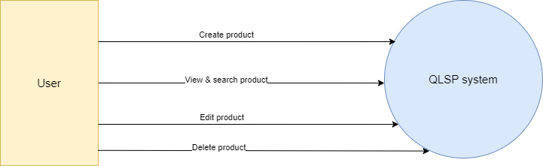

*Diagram: QLSP Context diagram*

## 2. User Requirements

### 2.1. Actors

**User:** A user who can view system’s metrics, manage the data.

### 2.2. Use Cases

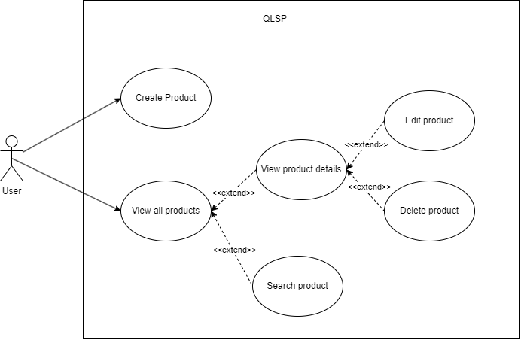

*Diagram: QLSP Use Case diagram*

## 3. Functional Requirements

#### 3.2.1. UC01 – Create Product

##### **a. Screen Layout**

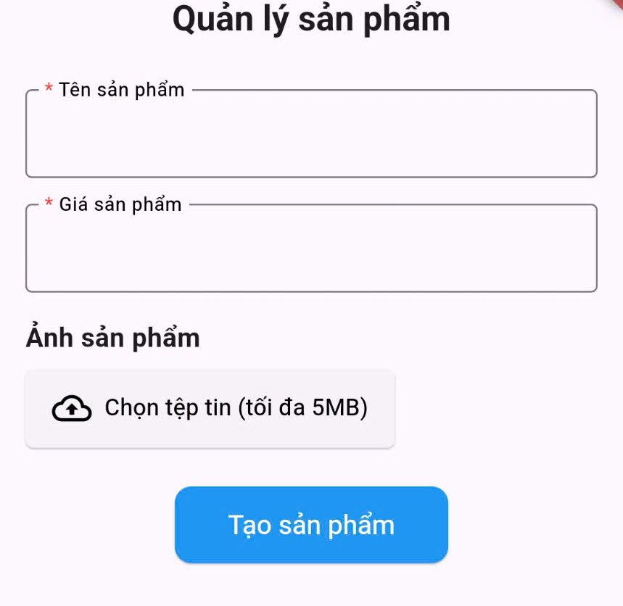

*Figure: QLSP Create Product*

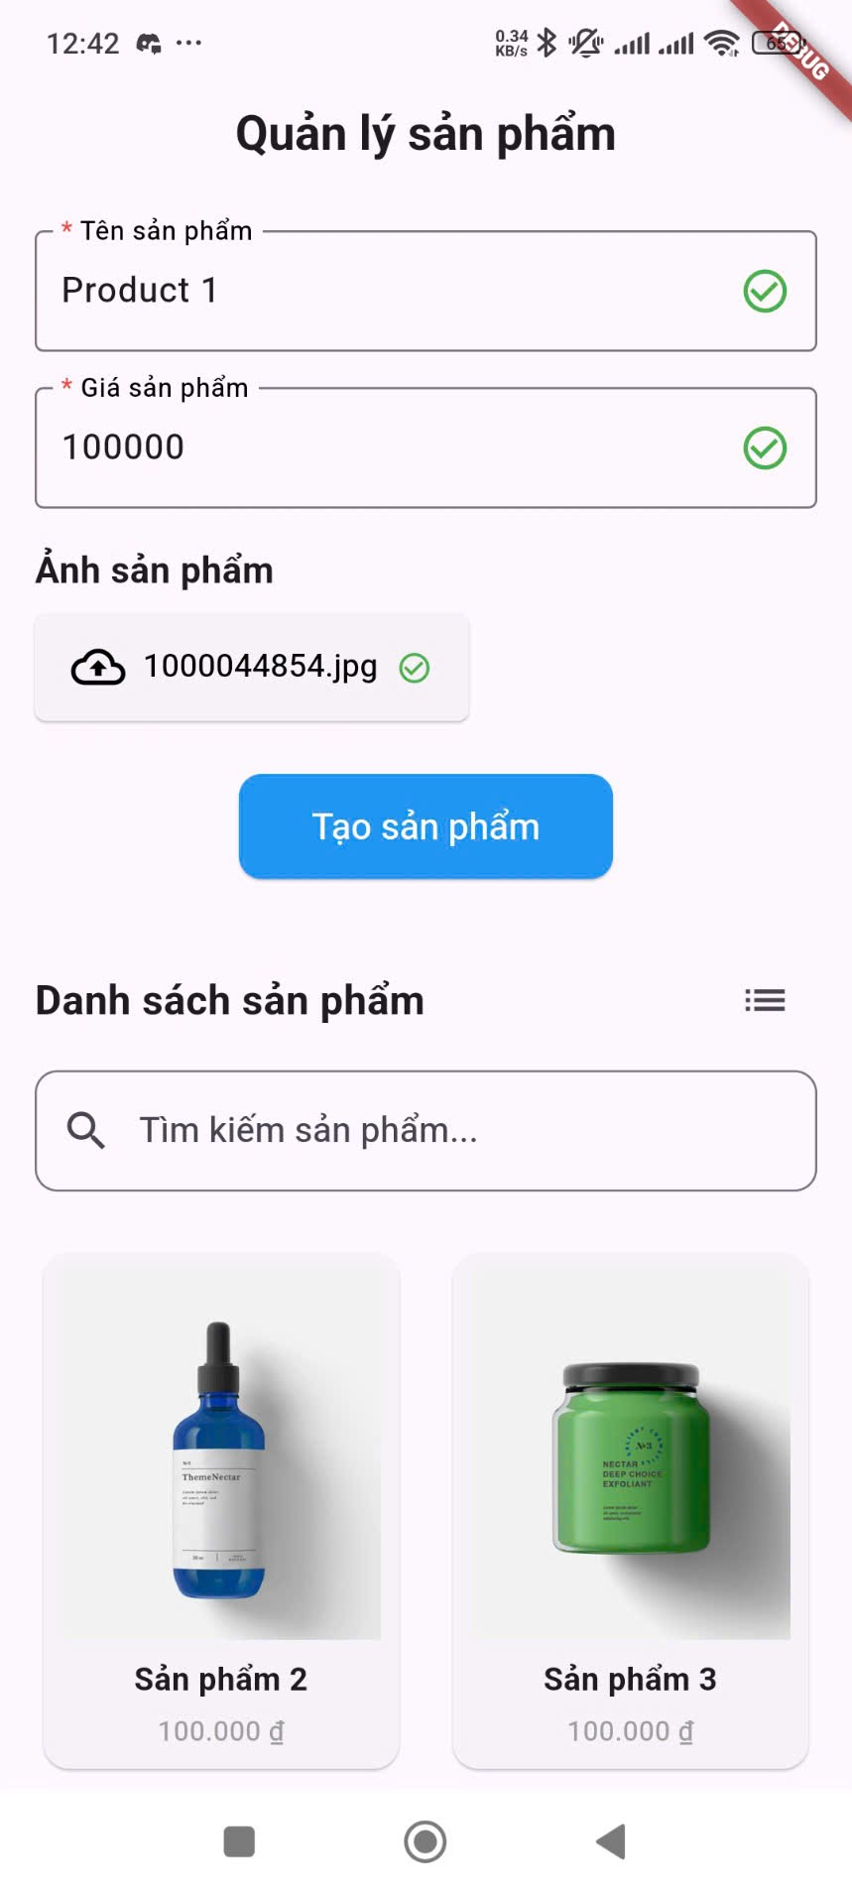

*Figure: QLSP Create Product - Valid*

##### **Use Case Specifications**

|  |  |  |  |
| --- | --- | --- | --- |
| **Use Case Nam** | **UC01 – Create Product** | | |
| **Primary Actor** | User | Secondary Actors: | None |
| **Description** | The user want to add a new product | | |
| **Normal Flow** | 1. User type in product name.  2. User type in product price.  3. User tap on the “Chọn tệp tin” button.  4. System displays user’s gallery for user to choose image from.  5. User choose their desire image.  6. System show image name and status  7. User tap on the “Tạo sản phẩm” button  8. System add the item, refresh the list and notify user. | | |
| **Alternative Flows** | N/A | | |
| **Exceptions** | **User Input Exceptions:**   * **Empty Product Name:** The user attempts to create a product without entering a name in the "Tên sản phẩm" field (which is indicated as required by the asterisk). * **Empty Product Price:** The user attempts to create a product without entering a value in the "Giá sản phẩm" field (also indicated as required). * **Invalid Product Price Format:** The user enters a value in the "Giá sản phẩm" field that is not a valid number (e.g., letters, symbols where only digits are expected). * **Product Price Below Minimum Value (if configured):** The application has a defined minimum price for products, and the user enters a value below this threshold. * **Product Price Above Maximum Value (if configured):** The application has a defined maximum price for products, and the user enters a value above this threshold. * **Product Name Below Minimum Length (if configured):** The application has a defined minimum length for product names, and the user enters a name shorter than this. * **Product Name Exceeds Maximum Length (if configured):** The application has a defined maximum length for product names, and the user enters a name longer than this. * **No Image Selected:** The user attempts to create a product without selecting an image via the "Chọn tệp tin" button. * **Invalid Image File Type:** The user selects a file that is not a supported image format (e.g., a document, a video). * **Image File Size Exceeds Limit:** The user selects an image file larger than the "tối đa 5MB" limit specified. | | |

*Table - QLSP Create Product*

# IV. Release Package & User Guides

## 1. Deliverable Package

| **No.** | **Deliverable Item** | **Description** |
| --- | --- | --- |
| 1 | Project Schedule/Tracking | A document or tool used to track project timelines, milestones, and progress. |
| 2 | Project Backlog | A prioritized list of all tasks, features, and requirements for the project. |
| 3 | Source Codes | The complete set of source code files for the project, including all versions and revisions. |
| 4 | Project Report | Final comprehensive report summarizing the entire project, including results and conclusions. |

## 2. Installation Guides

### 2.1 System Requirements

**Hardware Requirements:**

* Processor: Quad-core 2.4 GHz or higher (Intel i5 or equivalent recommended for Android Studio)
* Memory (RAM):
  + Minimum: 8 GB
  + Recommended: 16 GB (especially for Android Studio)
* Storage:
  + Minimum: 20 GB of free disk space
  + Recommended: More space may be required.

**Software Requirements:**

* Operating System: Windows 10/11, macOS 10.15 or later, or a Linux distribution (e.g., Ubuntu 20.04+)
* Node.js: Version 14.x or later
* npm (Node Package Manager): Version 6.x or later
* Android Studio: Ladybug or at least 3.0
* Visual Studio Code: any version (latest preferable)
* Flutter/Dart SDK: at least version 3.5.3
* A web browser: Chrome, Firefox, Safari, or Edge

**Relevant Configurations:**

* Environment variables configured for database connections and application settings
* Android Studio / Visual Studio Code require installation and configuration.
* Flutter/Dart SDK path requires configuration.

### 2.2 Installation Instruction

* **Android Mobile App:**

Link to the demo video: [How to install front-end module of project (Android Mobile)](https://youtu.be/-66LH0C6xps)

1. Install Flutter SDK from the following link:[Install | Flutter](https://docs.flutter.dev/get-started/install)

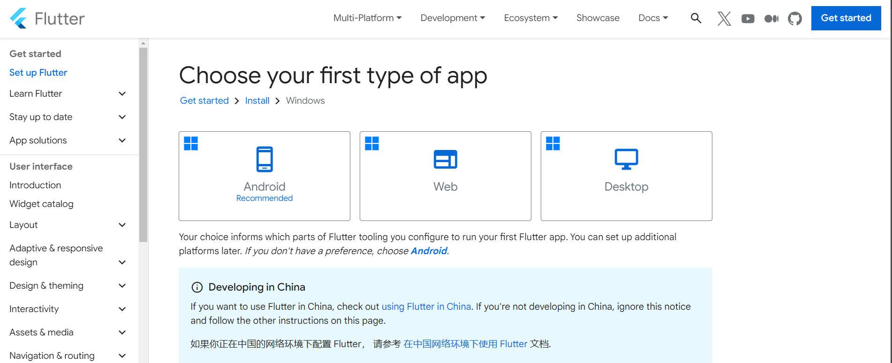

1. Setup Flutter SDK according to the instructions.

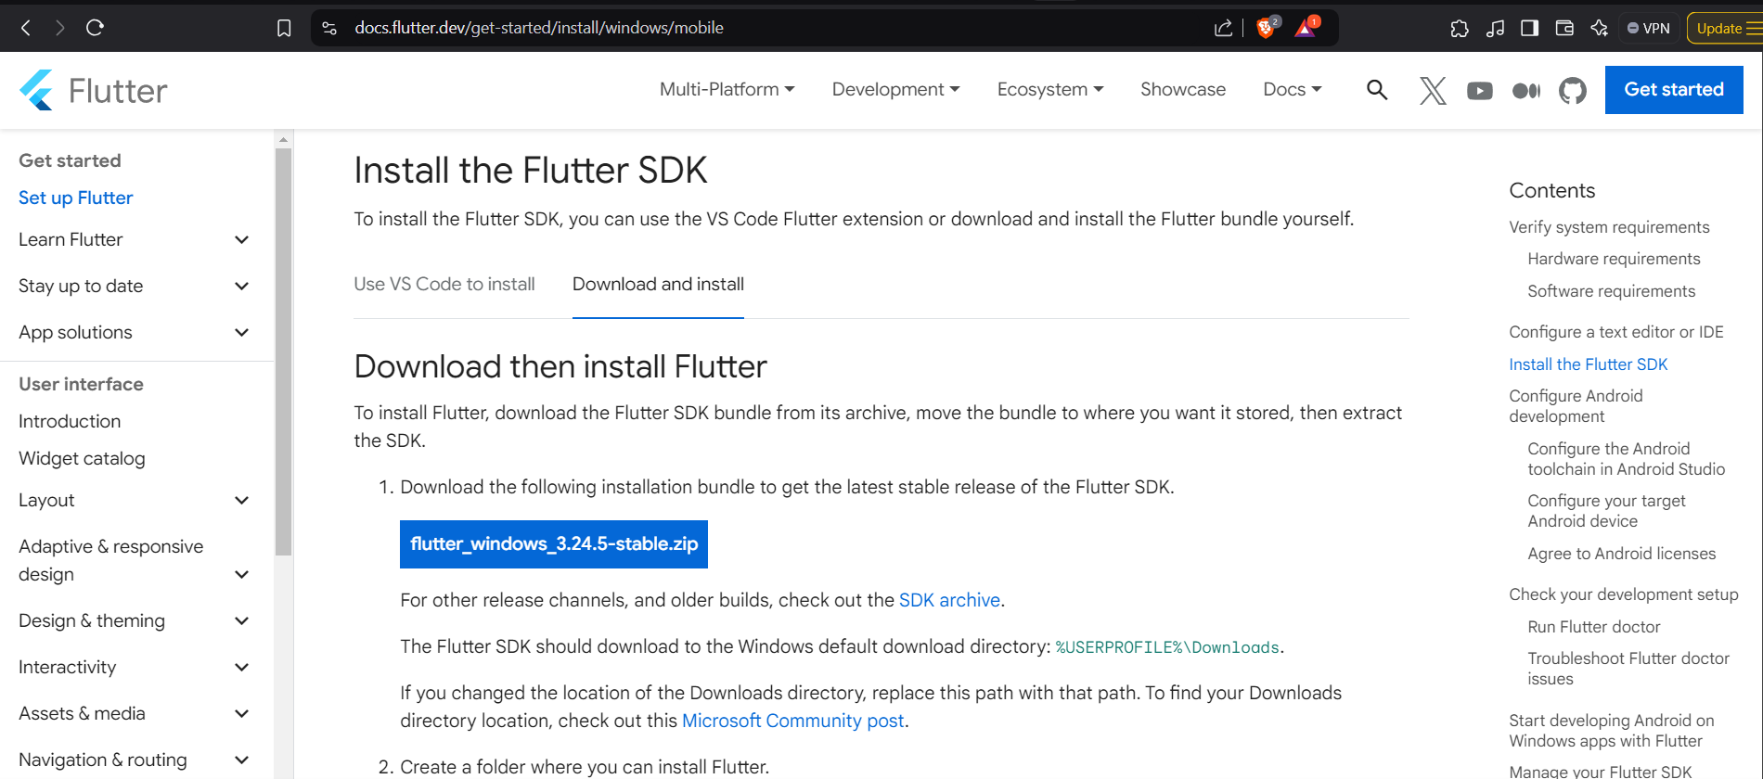

1. Install Android studio from: [Download Android Studio & App Tools - Android Developers](https://developer.android.com/studio) or using this terminal command: “winget install -e --id Google.AndroidStudio”

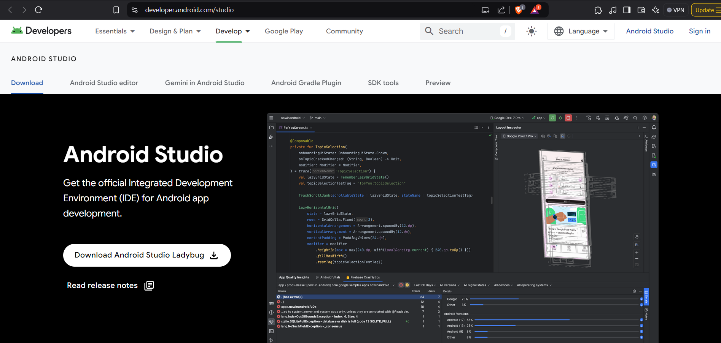

1. Install Flutter and Flutter Command Line Tools for Android Studio.

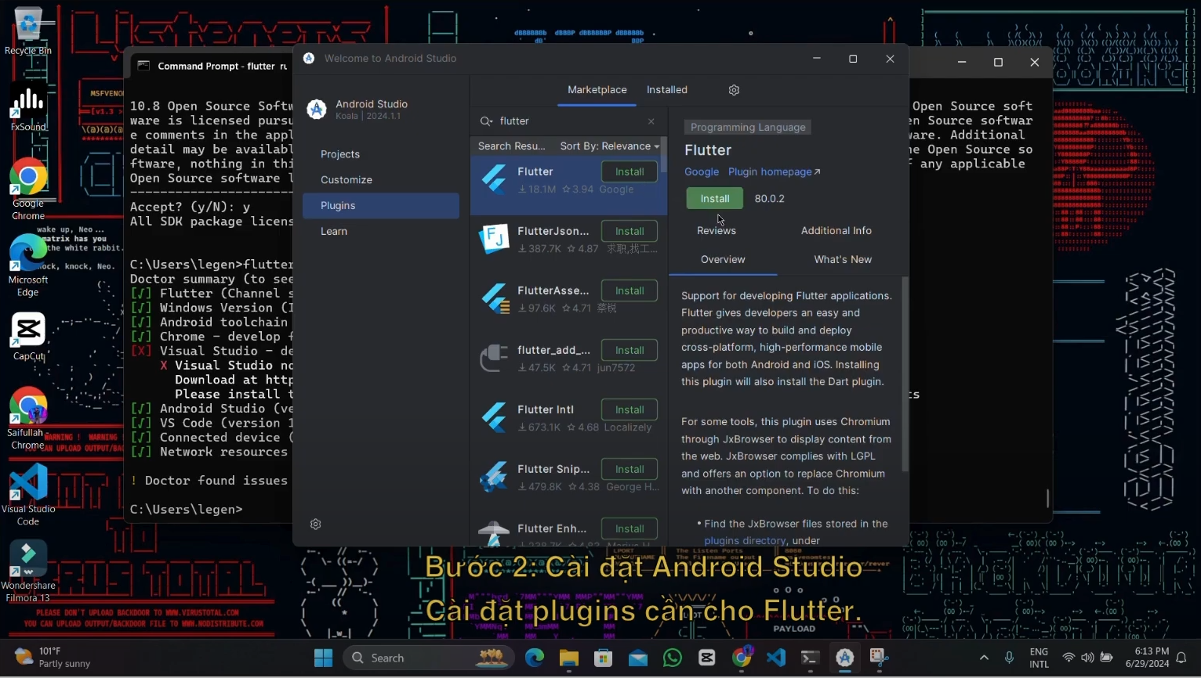

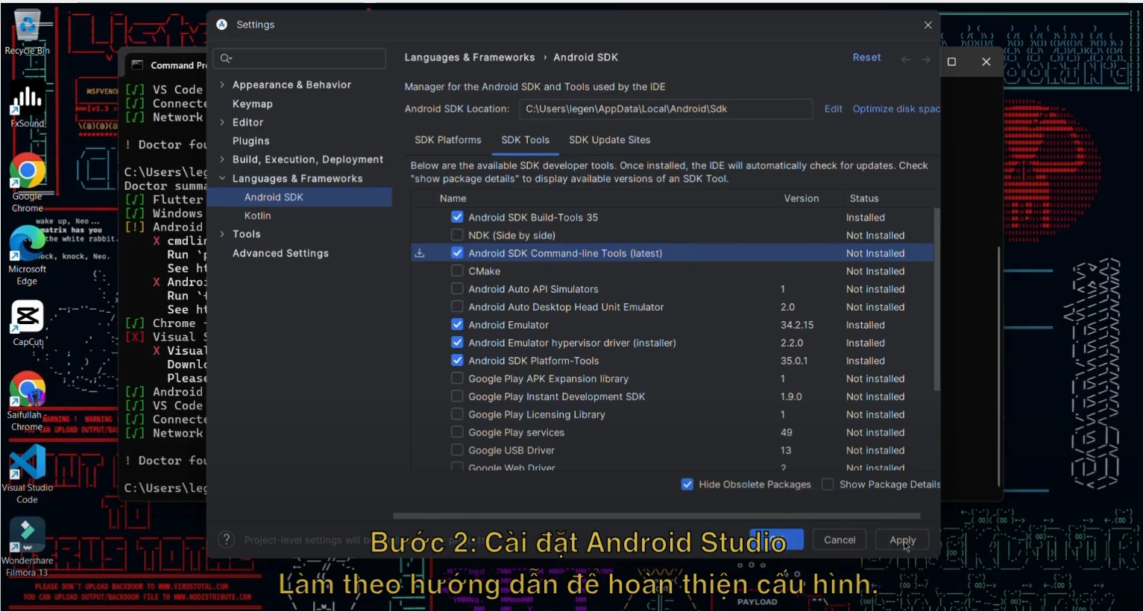

1. Install Android Studio emulator if needed.

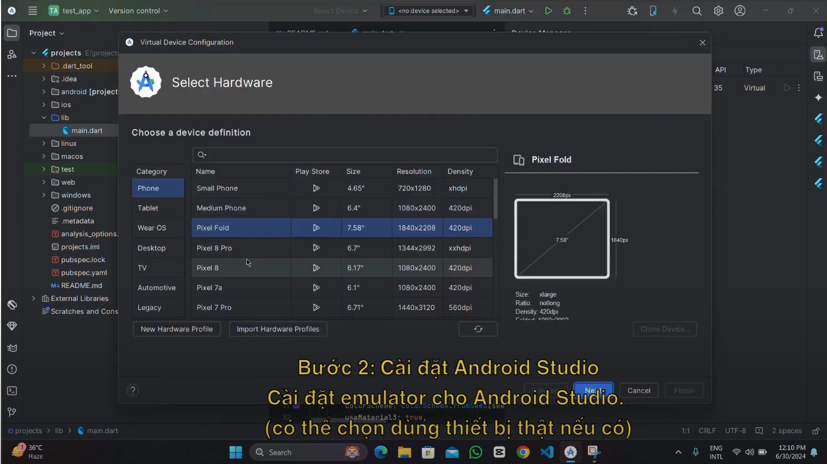

1. Configure Dart bin location for Android Studio.

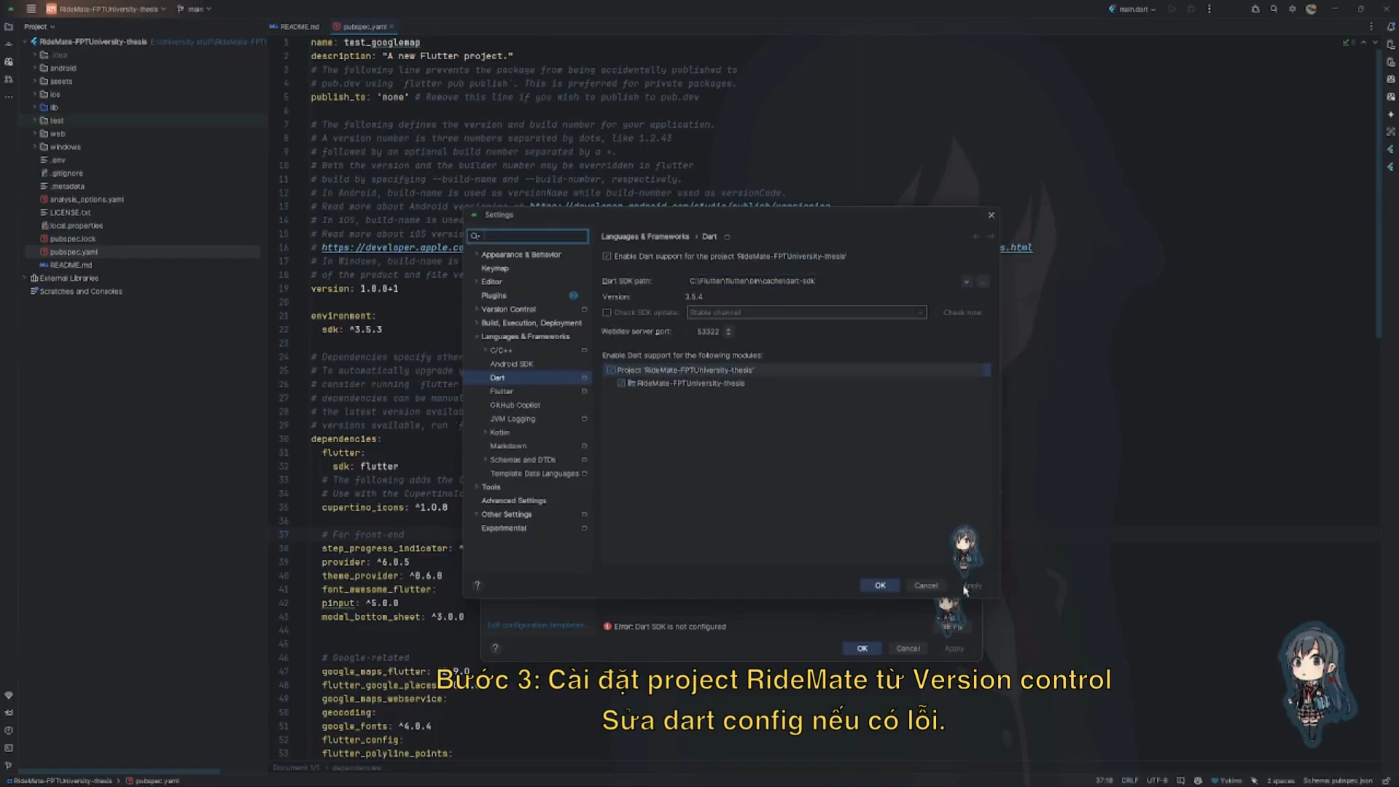

1. Pull Github repository: <https://github.com/khaikhaipq69/product_management.git>

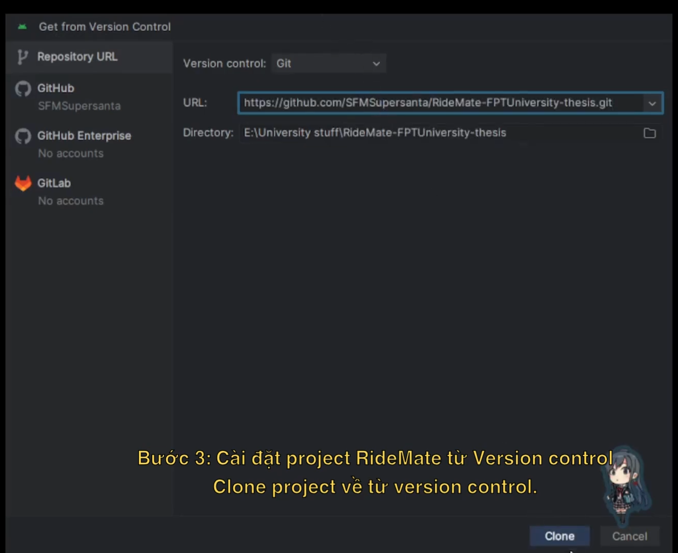

1. Run “pub get” from pubspec.yaml to get the required packages for the project.

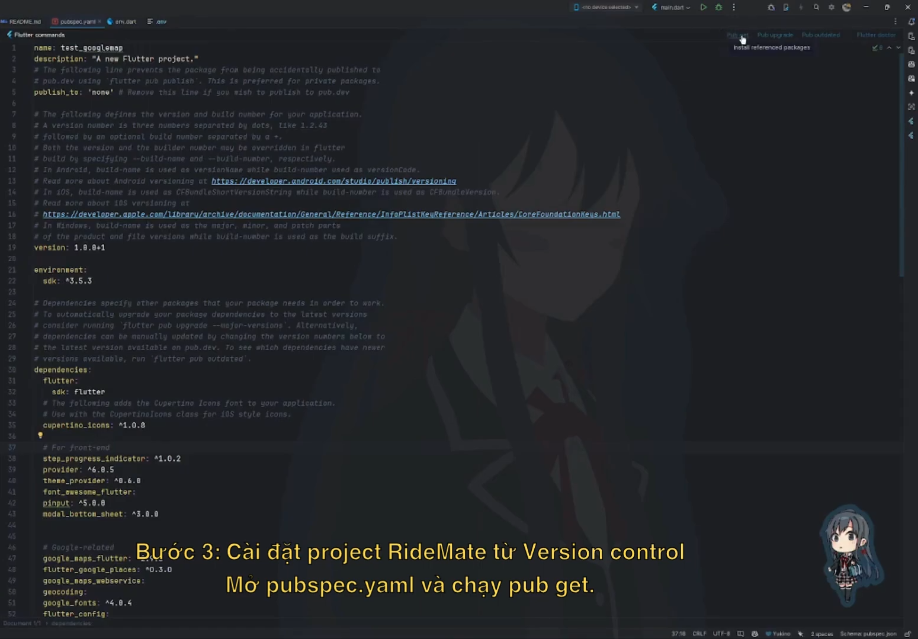

1. When the project is built successfully, a .apk file will be generated in *<project>/build/app/outputs/apk/debug/app-debug.apk*. Else you can use “flutter build apk --release” to get the release APK build in “build/app/outputs/flutter-apk/app-release.apk”.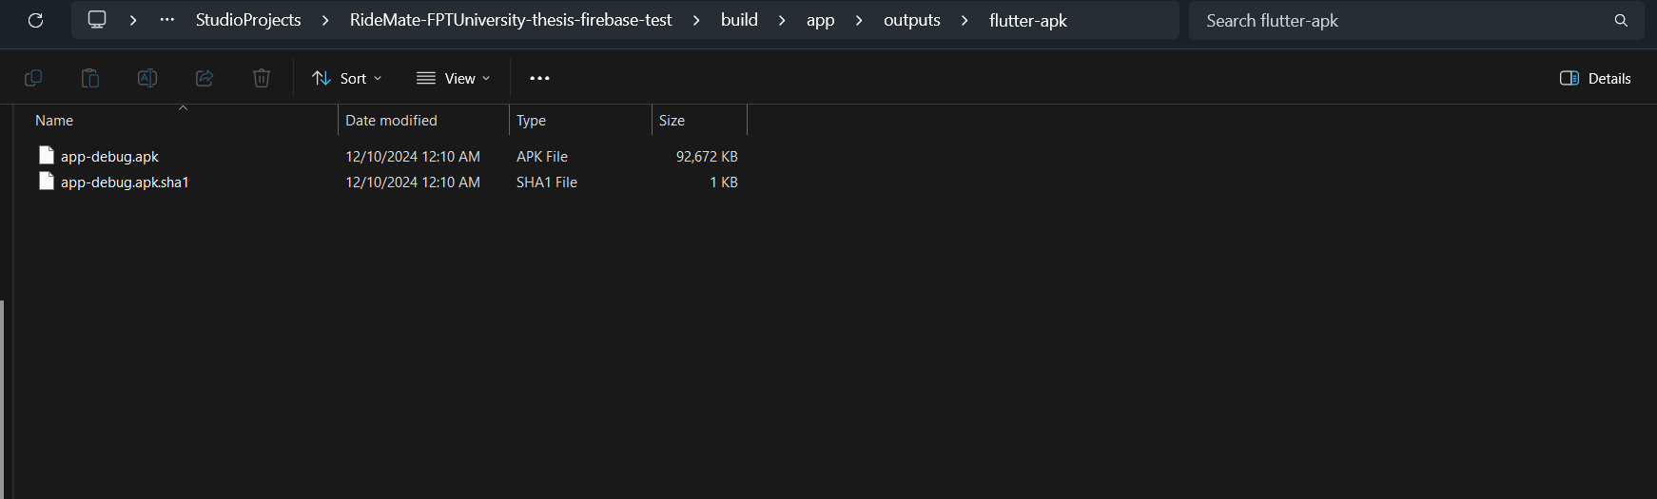

## 3. User Manual

### 3.1 Overview

* Here are the main features to help you understand how our app works.

#### 3.1.1. Create Product

This section explains how to add a new product to your product list.

Steps:

Navigate to the Home Screen: Upon opening the app, you will be directed to the home screen, which displays the product list and the product creation form at the top.

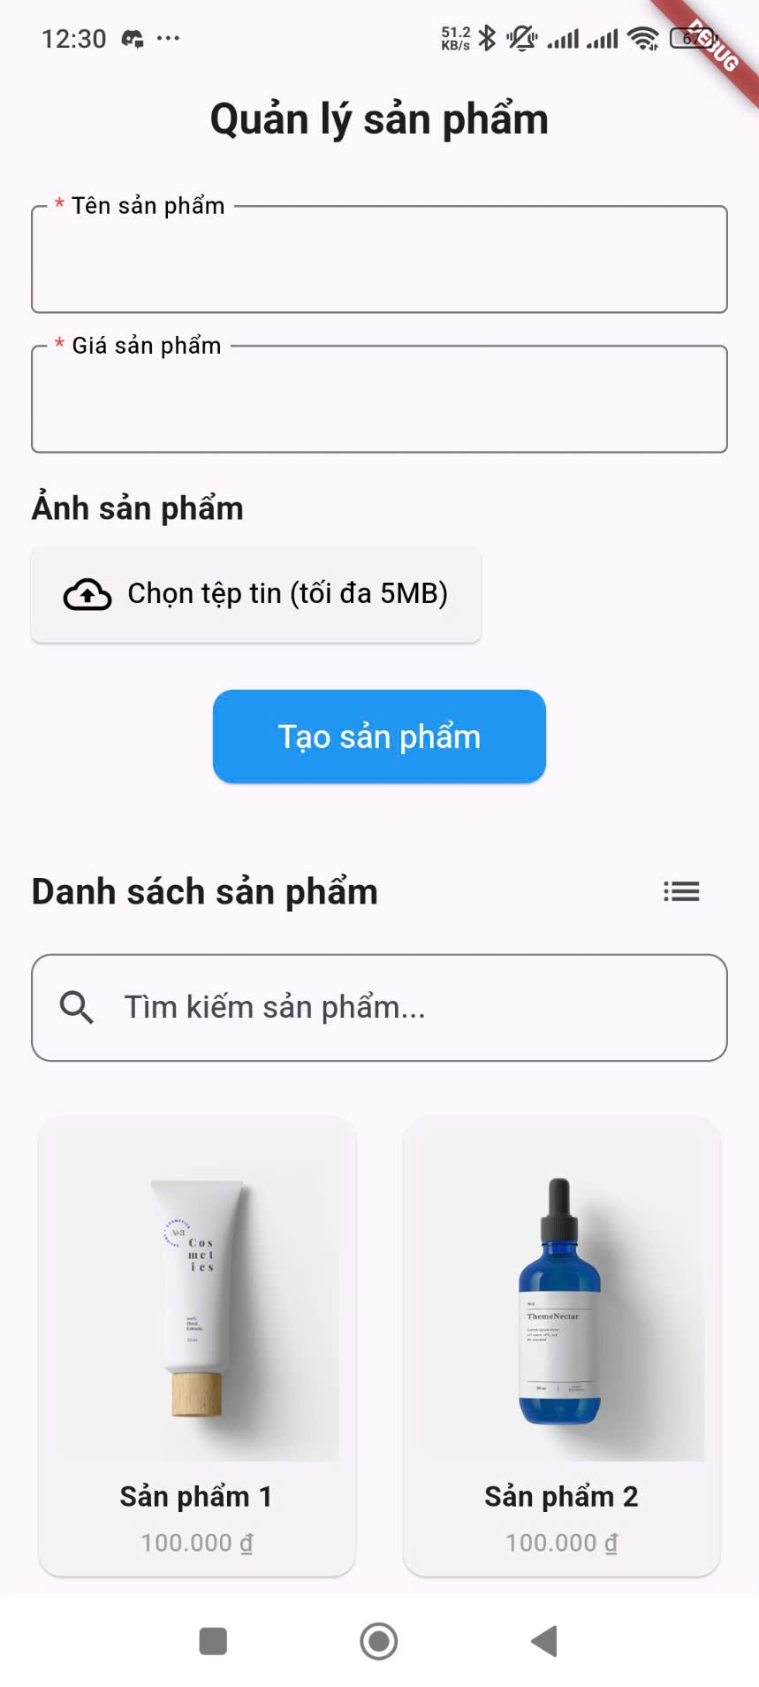

Enter Product Name: In the field labeled "Tên sản phẩm" (Product Name), tap on the text box and enter the name of your new product. This field is marked with an asterisk (*) indicating that it is required.

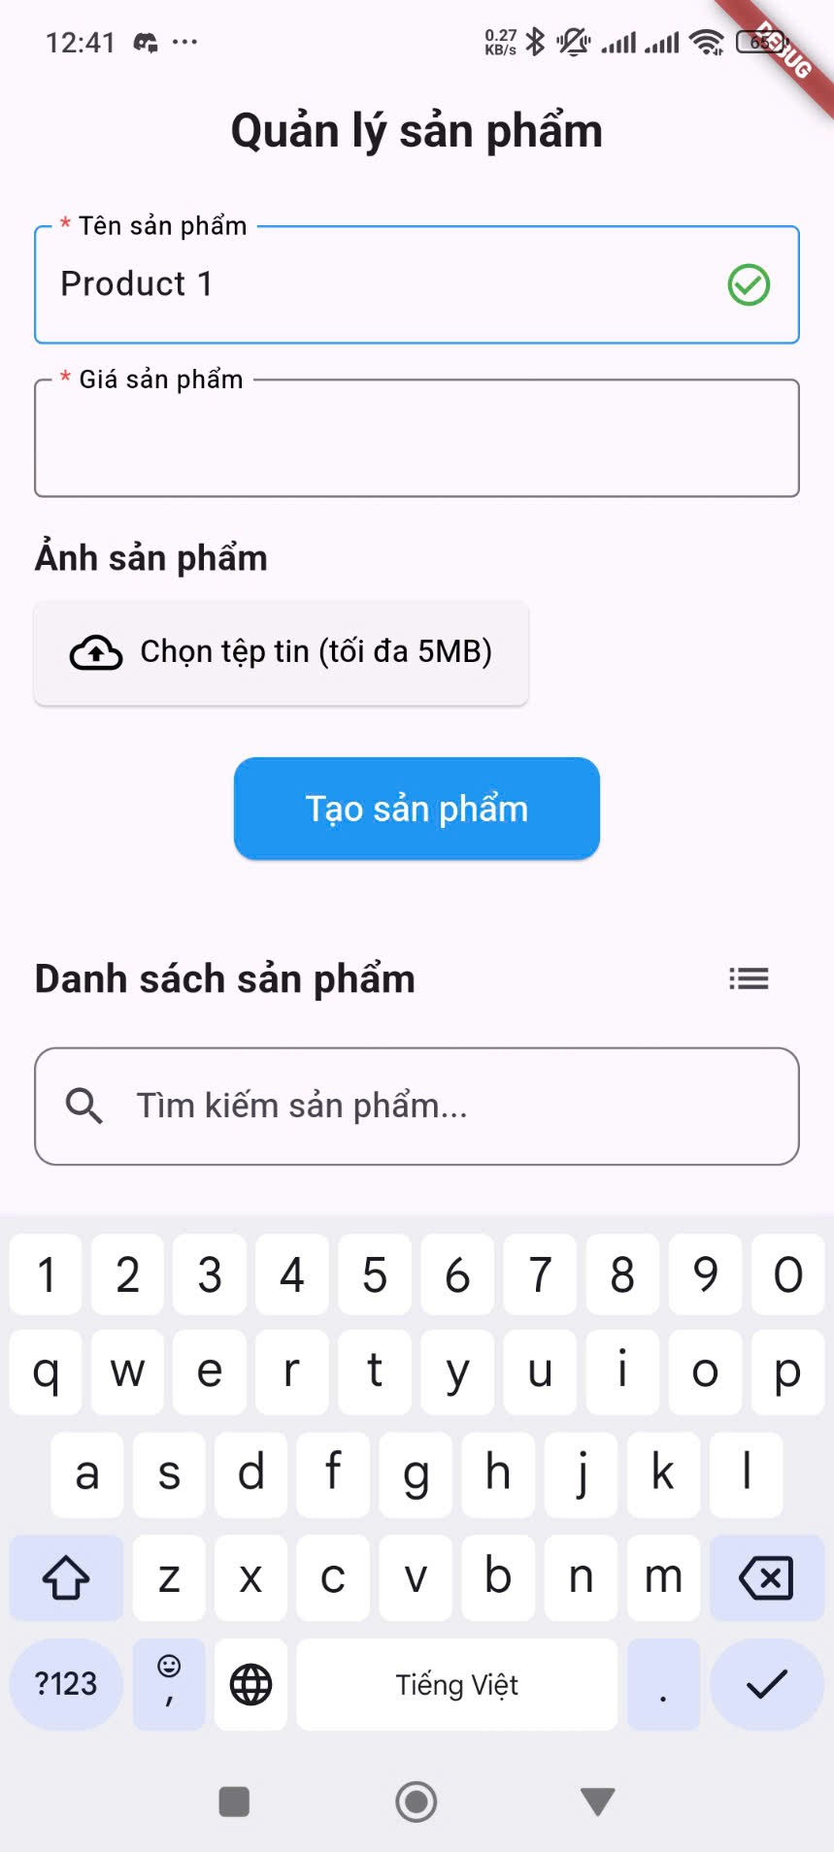

Enter Product Price: In the field labeled "Giá sản phẩm" (Product Price), tap on the text box and enter the price of your product. Please enter a valid number. This field is also marked with an asterisk (*) indicating that it is required.

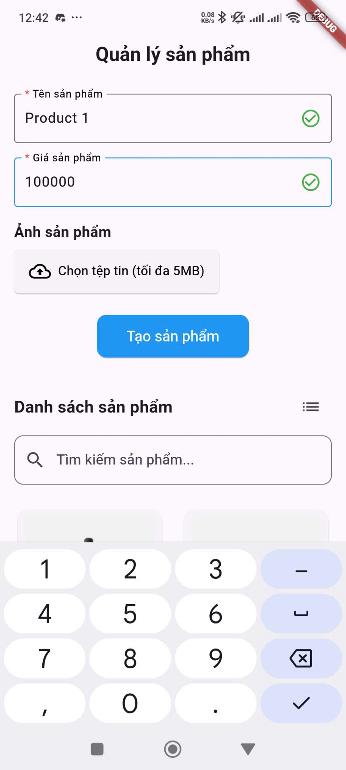

Note: The app may have validation rules for the price, such as minimum and maximum values. Ensure your entry falls within these limits if applicable.

Upload Product Image:

Tap on the "Chọn tệp tin (tối đa 5MB)" (Choose File (maximum 5MB)) button under the "Ảnh sản phẩm" (Product Image) section.

Your device's file explorer or gallery will open.

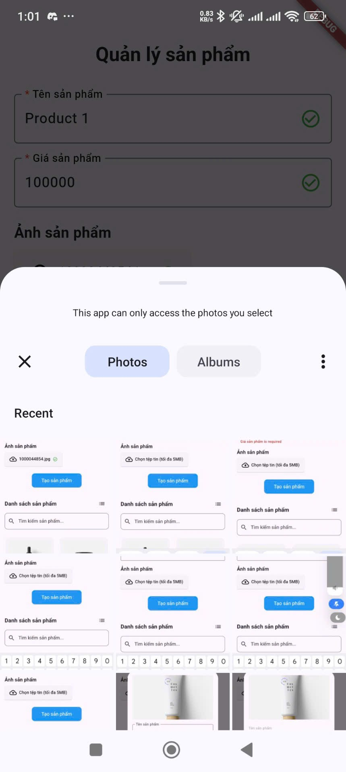

Browse and select the image you want to use for your product.

Once selected, the name of the image file will be displayed next to the button, along with a green checkmark icon indicating successful selection.



Note: The maximum file size for the image is 5MB. Only supported image formats (e.g., PNG, JPG) can be uploaded.

Submit Product Creation:

Once you have entered the product name, price, and selected an image, tap on the "Tạo sản phẩm" (Create Product) button located at the bottom of the form.

A confirmation message will briefly appear on the screen indicating whether the product was created successfully.

The newly created product will now appear at the top of the product list.

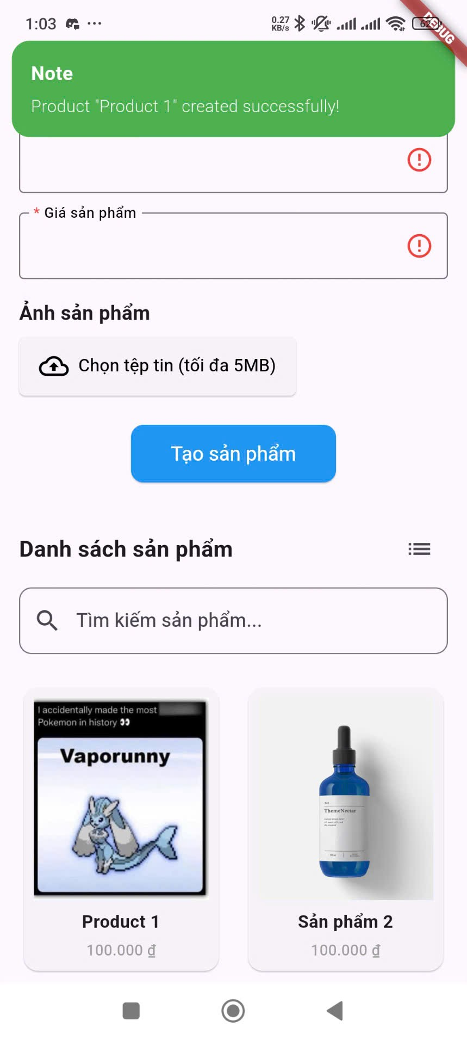

#### 3.1.2. View Product and View in Different Modes (Grid/List)

This section explains how to view your existing products in different layouts.

Viewing Products:

Upon opening the app, the main screen will display a list or grid of your products. Each product entry typically shows the product name and price. An image of the product may also be visible depending on the view mode.

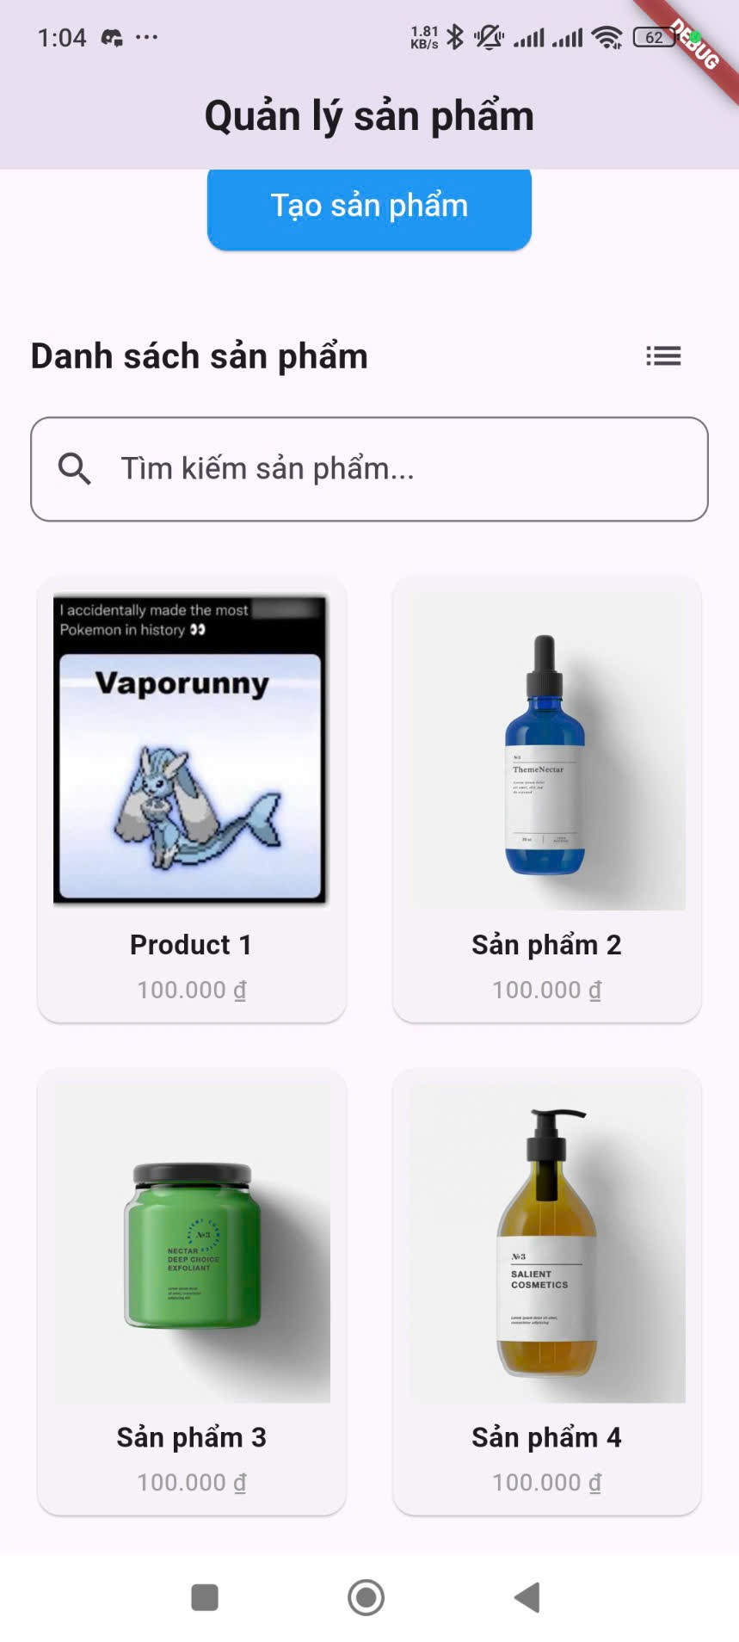

Switching Between Grid and List View:

Look for a view toggle icon (e.g., a grid icon or a list icon) usually located in the top right corner of the product list section.

To view products in a Grid layout: Tap on the grid view icon. Products will be displayed in a tile format, often showing the product image, name, and price.

To view products in a List layout: Tap on the list view icon. Products will be displayed in a vertical list, typically showing the product image (smaller), name, and price on each row.

The app will remember your last selected view mode for future use.

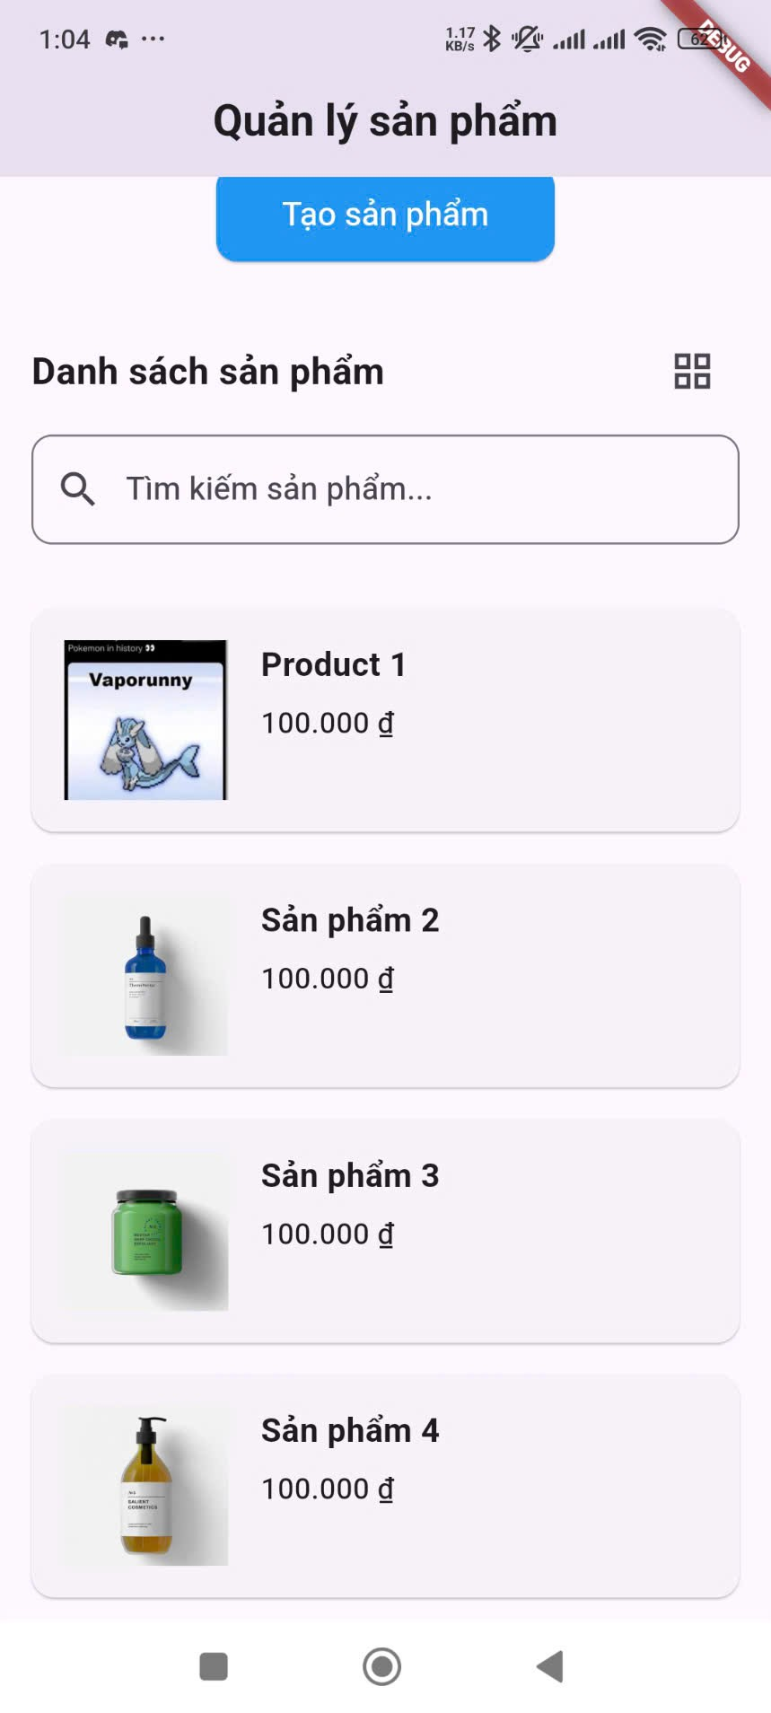

#### 3.1.3. Search Product

This section explains how to find specific products within your product list.

Steps:

Locate the Search Bar: On the home screen, look for a search bar, usually located at the top of the product list section. It might be labeled "Tìm kiếm" (Search) or have a magnifying glass icon.

Enter Search Term: Tap on the search bar and enter the name or keywords related to the product you are looking for.

View Search Results: As you type, the product list will automatically update to display only the products that match your search term.

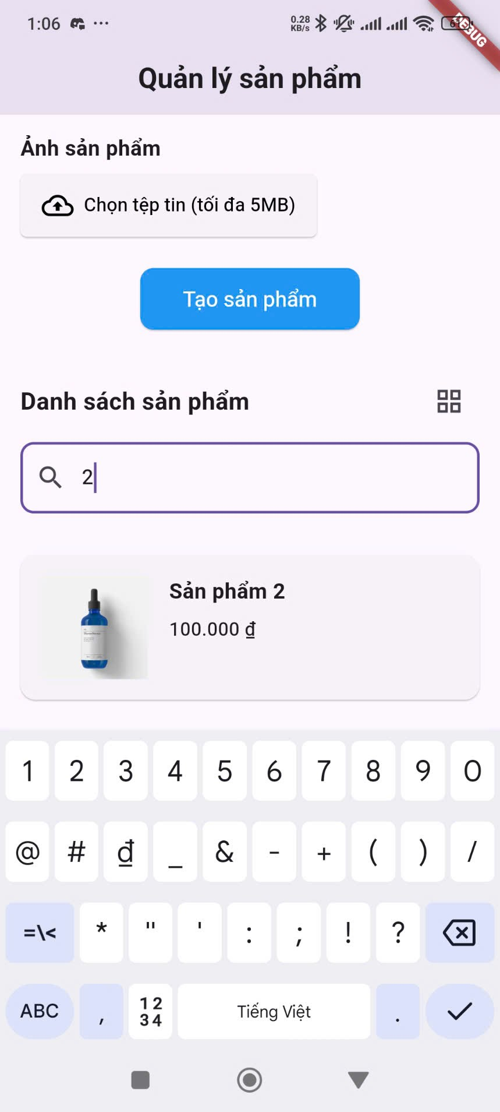

#### 3.1.4. Product Details

This section explains how to view detailed information about a specific product.

Steps:

Locate the Product: On the product list (either in grid or list view), find the product you want to view details for.

Tap on the Product: Tap anywhere on the product entry in the list or grid.

View Product Details: A pop-up window will appear displaying detailed information about the selected product. This typically includes:

A larger view of the product image.

The full product name.

The product price (formatted with the Vietnamese Dong symbol "₫").

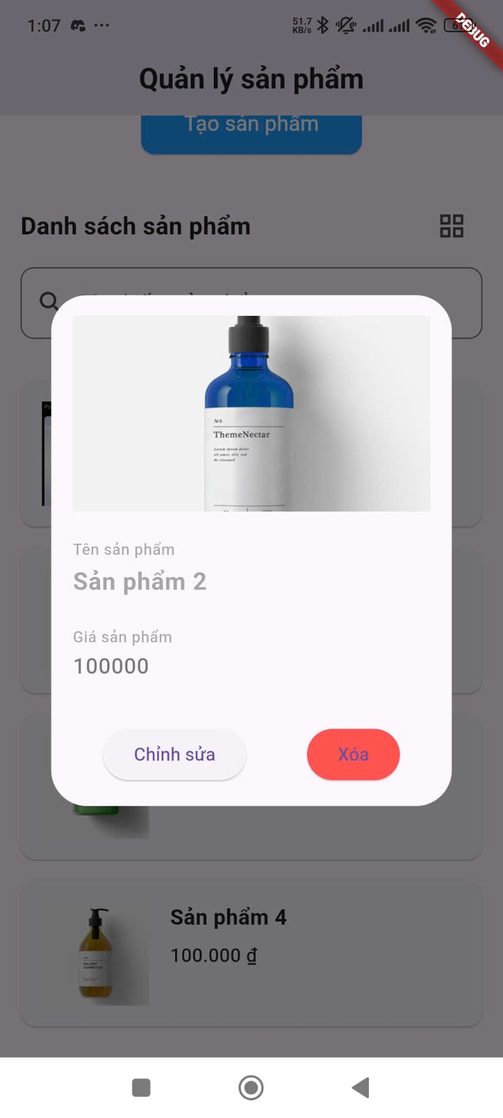

#### 3.1.5. Edit/Delete Product

This section explains how to modify or remove existing products from your inventory, accessed through the Product Details pop-up.

Accessing Edit/Delete Options:

View Product Details: Follow the steps in Section 4 to open the Product Details pop-up for the product you wish to edit or delete.

Locate Edit and Delete Buttons: Within the Product Details pop-up, you will find two buttons at the bottom:

Chỉnh sửa (Edit): Usually located on the left.

Xóa (Delete): Usually located on the right and may be styled with a different color (e.g., yellow or red).

Editing a Product:

Tap "Chỉnh sửa" (Edit): Tap on the "Chỉnh sửa" button.

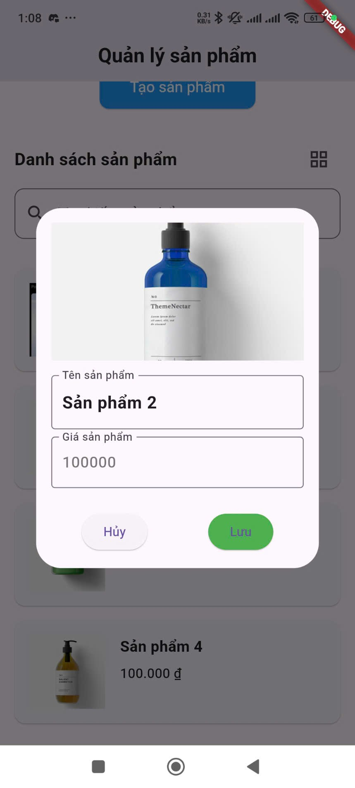

Edit Product Information: The product name and price fields in the pop-up will become editable.

Tap on the "Tên sản phẩm" field to modify the product name. Ensure you adhere to any length or format requirements.

Tap on the "Giá sản phẩm" field to change the product price. Enter a valid number within any specified range.

Save Changes: The "Xóa" button on the right will now change to "Lưu" (Save) and its color may change (e.g., to green). Tap on the "Lưu" button to save your changes. A confirmation message will appear, and the product details in the list will be updated.

Cancel Editing: If you decide not to make any changes, tap on the "Hủy" (Cancel) button that replaces the "Chỉnh sửa" button. The fields will revert to their original values.

Deleting a Product:

Tap "Xóa" (Delete): In the Product Details pop-up, tap on the "Xóa" button.

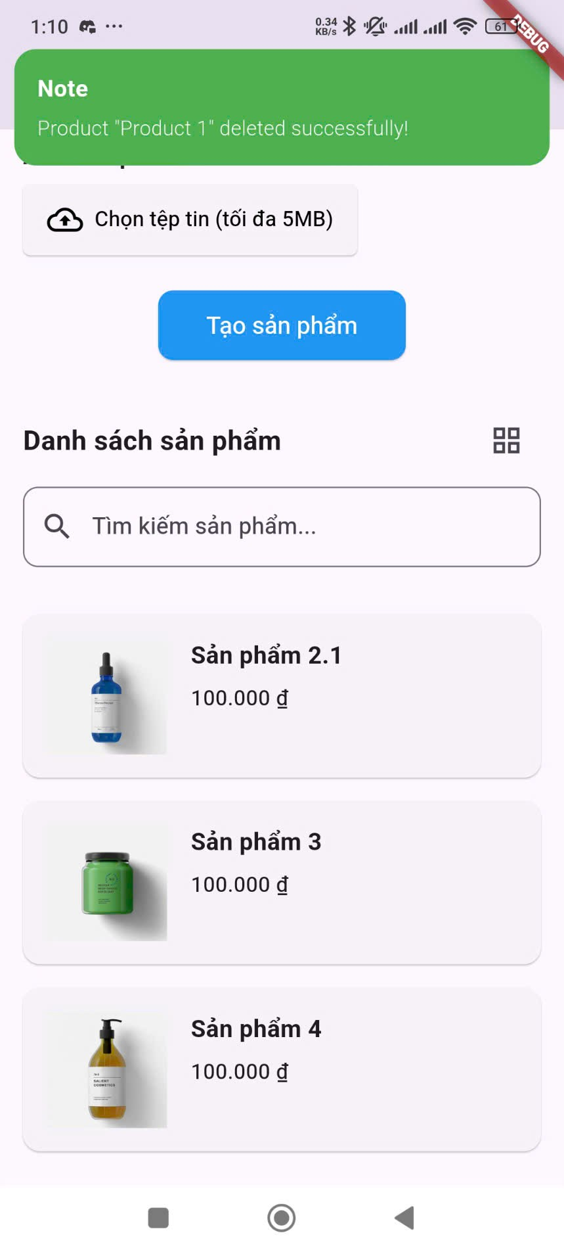

This user manual should help you navigate and use the key features of the QLSP product management application. If you encounter any issues or have further questions, please refer to the in-app help or contact support.